
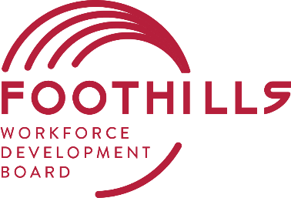
On-the-Job Training Program

The Foothills Workforce Development Board offers On-the-Job Training (OJT) options for employers who agree to hire eligible customers. These customers can do the job but may lack either the education or training required to meet all the job requirements. In exchange for training that employee and giving him/her the opportunity to work, the employer may be reimbursed a percentage of the trainee’s wages for a specified training period.
On-the-job training allows the employer to hire an individual and get him or her through an initial training period without investing a large sum of money. It also provides the job seeker an opportunity for a job that he/she might not have had without the benefit of OJT.
What is the benefit to my company for providing On-The-Job Training? The employer is reimbursed a percentage (50% ) of the employee’s training cost based on the trainee’s wage for the duration of the contracted training period and company demographics.
How long is the training service? The length of the contract is determined by training standards and is based on the specific learning skill level required to do the job. Most contracts are 3-6 months.
How is the training service designed? A contract is written based on the standard occupational requirements for that specific job; the employer’s needs and requirements for the job; and the skills the customer possesses and brings to the job. A representative of the Workforce Board and an authorized representative of the business must sign the contract before the customer starts to work.
How Do I know the applicant referred to my company has the aptitudes for the job? The customer is interviewed, assessed and receives career counseling to ensure that he/she has the aptitudes necessary for succeeding in the job.
Interested in hiring an employee through the OJT Program? Foothills Workforce Development Board’s Business Services Representative would be happy to meet with you to explain the details of the program:
Sarah Crank (BSR)
(828) 748-6083
C (828) 447-7100

